# PROJECT DESIGN PHASE-II

Data Flow Diagram & User Stories

|  |  |
| --- | --- |
| Date | 25 October 2022 |
| Team ID | PNT2022TMID19437 |
| Project Name | Personal Assistance for Seniors Who Are Self- Reliant |

**Data Flow Diagrams:**

A Data Flow Diagram (DFD) is a traditional visual representation of the information flows within a system. A neat and clear DFD can depict the right amount of the system requirement graphically. It shows how data enters and leaves the system, what changes the information, and where data is stored.

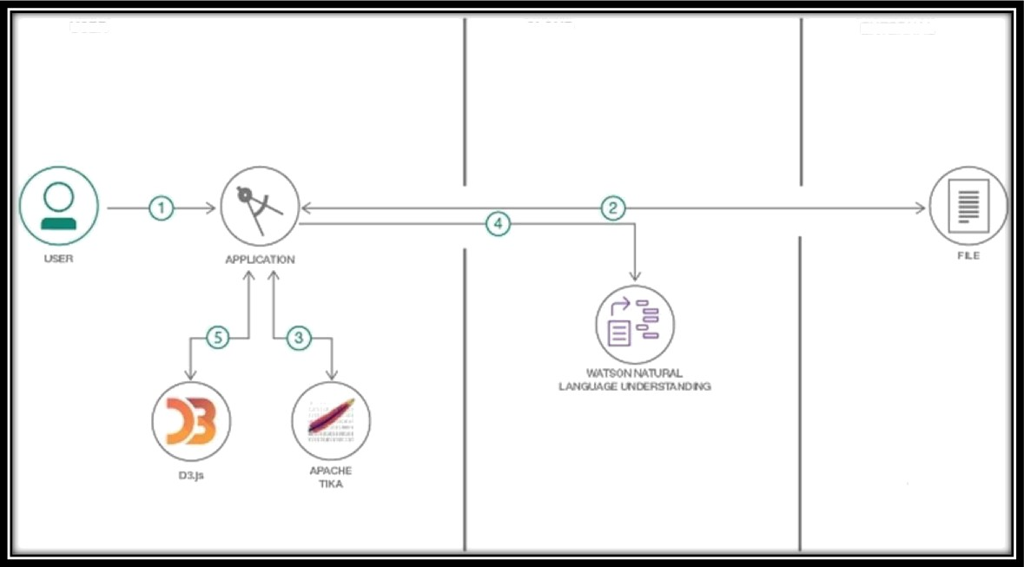

USER

CLOUD

EXTERNAL

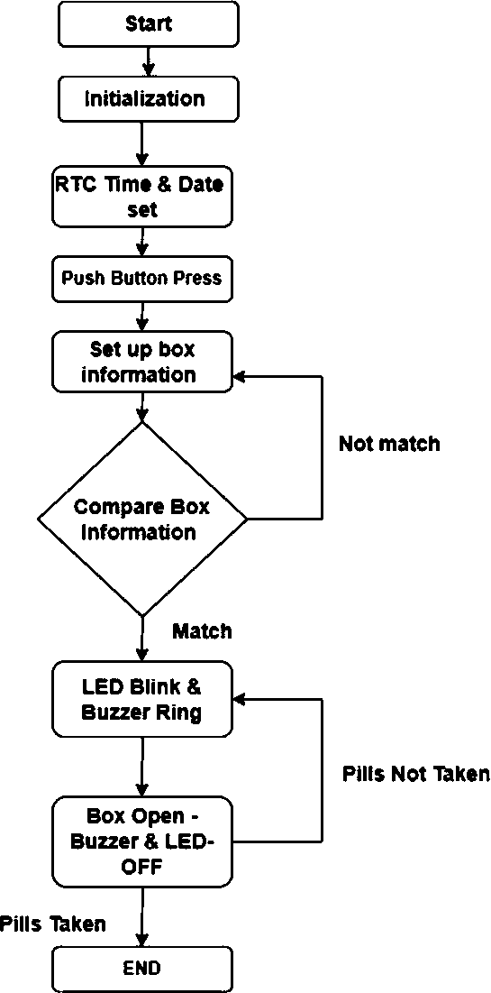

User Stories

|  |  |  |  |  |  |  |
| --- | --- | --- | --- | --- | --- | --- |
| **User Type** | **Functional Requirement (Epic)** | **User Story Number** | **User Story / Task** | **Acceptance criteria** | **Priority** | **Release** |
| Customer (Senior citizen) | Caretaker | USN-1 | As a user, I want to take Medicines on time and monitor my health | I want to Take Medicines On time | High | Sprint-1 |
| Customer (Alzheimer patient) | Smart medicine box | USN-2 | As a user, I want to take my tablets on time by voice command | I want to take my tablets on time by voice  command | High | Sprint-1 |
| Customer (Mentally idled patient) | Caretaker | USN-3 | As a user, my patient needs to take medicines on time and monitoring the activity | My patient needs to take medicines on time | Medium | Sprint-2 |
| Customer (Coma patient) | Caretaker | USN-4 | As a user, my patient medication time and prescription should load in database for upcoming week | My patient medication time and prescription should be in database list | Low | Sprint-4 |
| Customer (Disabled people’s) | Smart medicine box | USN-5 | As a user, I need to take my medicine in nearby places with light notification | I need to take my medicine in nearby places with light notification | Medium | Sprint-3 |